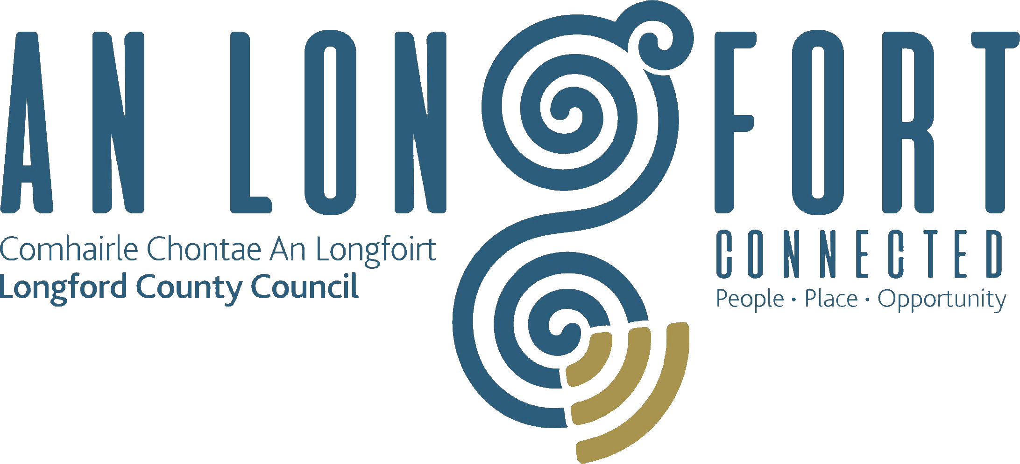

Minutes of Joint Policing Committee Meeting held in the Council Chamber,
Aras an Chontae, Longford on
Monday, 6th July 2020 at 3.00 p.m.

PRESIDING: Councillor Seamus Butler.

PRESENT: Councillors - Uruemu Adejinmi, John Browne,
Gerry Hagan, Martin Monaghan, Garry Murtagh,
Peggy Nolan, P.J. Reilly, Paul Ross, Pat O’Toole.
James Belton, Angela Keaveny, Ndidi Idehen.
Deputy Sorcha Clarke.
Deputy Joe Flaherty.

Mr. Paddy Mahon, Chief Executive.
Mr. Ciaran Murphy, Senior Executive Officer.
Ms. Barbara Heslin, Director of Services.
Chief Superintendent Tony Healy.
Superintendent Jim Delaney.
Inspector Dave Jordan

APOLOGIES:- Councillors - Turlough McGovern and Gerry Warnock.
Niamh Donlon, Emma Kiernan and Pat Murphy.
Superintendent Seamus Boyle.

MEETINGS
ADMINISTRATOR: Anne Lee.

VOTE OF SYMPATHY.

A vote of sympathy was extended to the family and colleagues of the late
Detective Garda Colm Horkan.

ADOPTION OF MINUTES.

On the proposal of Councillor P. O’Toole seconded by Councillor P.J. Reilly, it was unanimously agreed to adopt the minutes of Joint Policing Committee meeting held on the 2nd March 2020, as circulated.
MATTERS ARISING.

None.

DECLARATION OF INTERESTS.

None

GARDA REPORT

Criminal Assets Bureau (CAB) Raid.

Councillor Butler and the members complimented the local Gardai and all who were involved in the successful CAB operation in County Longford earlier in the day.

Chief Supt. Tony Healy briefed the members regarding this morning’s operation and also complimented all who were involved.

Superintendent Delaney briefed the members on the following and replied to queries raised –

- Assault causing harm.
- Burglaries.
- Drugs seizures.
- Thefts from Shops.
- Proactive engagements.
- Roads policing.
- Community Policing – particularly relating to COVID.
- Involvement in the Community Forum.
- High visibility policing.

Inspector Dave Jordan briefed the members on the following and replied to queries raised –

- Proactive policing
- Burglaries.
- Criminal Damage.
- Assaults.
- Public Order offences.
- Domestic violence.
- Drugs offences.
- Ongoing feuds.
- Community Policing – particularly relating to COVID.
- Staffing resources.
- Roads policing.

LOCAL AUTHORITY REPORT.

C. Murphy provided an update on the following and replied to queries raised –

- Community Response Forum/ Community Call initiative.
- Supports being provided to businesses during COVID-19, both financial and non-financial, available through Longford County Council and Longford LEO
- Funding programmes.
- Community engagement.
- Sports Partnership programme.
- Housing programme.
- Library programme.
- Regeneration and Tourism programmes.

Councillor Butler proposed and Councillor P. Nolan seconded that the Garda and Local Authority reports be circulated to the members in advance of the JPC meetings, and if the members have any queries, responses can be given at the relevant JPC Meeting.

NOTICE OF MOTION SUBMITTED BY COUNCILLOR GARRY MURTAGH AT MARCH 2020 LONGFORD COUNTY COUNCIL MEETING.
Councillor Murtagh briefed the members regarding the following Notice of Motion which he submitted to the March meeting of the County Council -
“I am calling on Longford County Council to invest in a countywide communication service, to connect and deliver messages from agencies such as Garda Emergency/Text alerts, County Council and Local Community Groups.
A free service for the people of Longford thus supporting the efforts of the Garda, Joint Policing committee (JPC) and the wider communities within the county of Longford.
Monaghan County Council are running a similar initiative (delivered by Komeer) which has proven to be very successful in providing regular communications to its members.
Komeer are happy to deliver a presentation to Longford County Council/Joint Policing Committee.”
It was agreed that Councillor Murtagh’s proposal will be considered further by Longford County Council in the context of funding arrangements.

UPDATE ON LONGFORD JOINT ACTION PLAN.

Longford Joint Action Plan.

P. Mahon stated that work on building community capacity, through local community groups, is ongoing.

DATE OF NEXT MEETING

7th September 2020.

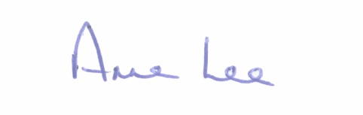
This concluded the business of the meeting.

Signed:
Anne Lee,
Meetings Administrator.

Confirmed and adopted at Joint Policing Committee Meeting held on the
7th September 2020.

Signed: __________________
Chairperson.

